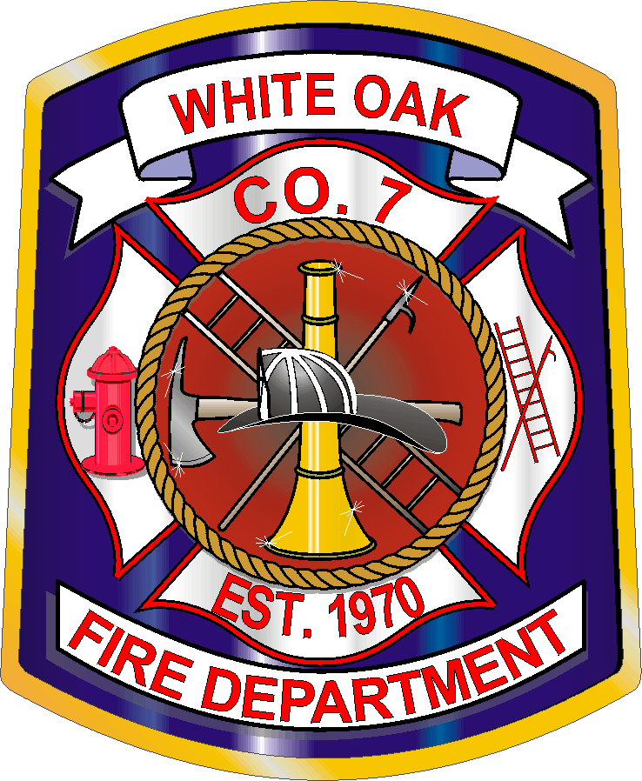
White Oak Volunteer Fire Association
12 Newton Road Fredericksburg, VA 22405
(540) 658-5337

_____________________________________________________________________________________

BANQUET HALL RENTAL AGREEMENT

This AGREEMENT, made and entered into this _____ day of _________________, 20____, by and between the WHITE OAK VOLUNTEER FIRE ASSOCIATION, hereinafter called “lessor”, Party of the first part, and ____________________________ hereinafter called “lessee”, Party of the second part, witnesseth:

The lessee requests to rent the hall on ___________________, 20____ for the following type of event: _______________________________________. The lessee hereby agrees to pay the lessor the sum of $_________ for the hall herein leased. A Security Deposit in the amount of $_________ will be required at contract signing from lessee. Deposits and Rental Fee shall be in the form of a Cashier’s Check, Certified Check, or Money Order. PERSONAL CHECKS ARE NOT ACCEPTED.

Security deposit will be returned when the function has concluded and after Building is cleaned, to include sweeping, mopping of all floors, emptying of all trash in kitchen, bathrooms, banquet hall and parking lot. All tables and chairs must be placed back wheeled racks, all lights turned off, heat and/or air conditioning set at 70 degrees, and there must be no damage to the building or property of the White Oak Volunteer Fire Department. The lessee is responsible for any damage to the building or property exceeding the deposit amount, the lessee will pay all cost of a contractor to repair the damage. The lessor and lessee will conduct an “end of event walk-thru” after the event to assure the facility has been cleaned, damaged free and everything was put away. The lessor will not return deposit if lessee does not abide by this contract.

***ATTENTION***
“NO WALL HANGINGS ALLOWED ON RENTAL HALL WALLS”.
(IF USED DEPOSIT WILL BE FORFEITED)

The White Oak Volunteer Fire Department has the right to hold a security deposit in the event that the lessee cancels within 30 days of the function.

The lessee must be 21 years of age or older to rent the hall. The lessee must request the hall at least two (2) weeks in advance and no more than twelve (12) months in advance. The request will not conflict with Association activities, and will be available on a first come first served basis. The lessee must obtain an ABC license if alcohol will be on property or in the building and provided a copy of the license before the day of the event. No alcohol is to be consumed by anyone attending a party under the age of 21.

Note: White Oak Volunteer Fire Department reserves the right to assign Security to an event if they see necessary cause. The Lessee would be responsible for the fee, which will be determined and discussed before rental agreement is signed.

Note: The Hall and Kitchen have 24/7 Security Cameras in operation.

The lessee will be responsible for the following:
- ABC Laws (Alcohol Beverage Control)
- State and Local Laws
- Building and Property
- All Functions to conclude no later than 12AM
- NO GAMBLING at any time
- NO FUNCTIONS THAT INVOLVE LEWD SEXUAL ACTS
If the Rental Agreement is not enforced, the Building Rental Coordinator and/or Department Vice President will take action:
- Forfeit security deposit
- Legal action if required
- Collections Agency notified is necessary

This Rental Agreement must be approved and signed by the Building Rental Coordinator to confirm the reservation of the Banquet Hall. The Vice President of the Department will resolve any conflicts regarding the Banquet Hall Rental that the Building Rental Coordinator cannot resolve, and his decision will be final.

White Oak Volunteer Fire Association will not be responsible for any accidents and/or illness that occur on the property during a function.

The parties to this AGREEMENT agree mutually that it shall be binding upon them, and that this AGREEMENT, unless amended in writing, contains the final and entire AGREEMENT between the parties hereto, and that they shall not be bound by any terms, conditions, oral statements or representations not herein contained.

LESSEE

_________________________________________ ______________________
Signature Date of Event

_________________________________________ ______________________
Address Phone

_________________________________________
Email

LESSOR

__________________________________________
Signature
------------------------------------------------------------------------------------------------------------
FIRE DEPARTMENT USE ONLY

Security Deposit Received: ______________ __________ _____________
DATE Amount Received By

Rental Check Received: ______________ __________ _____________
DATE Amount Received By

Per Event Walk-thru: _________ ______________________________________
DATE Completed By: (signatures)

After Event Walk-thru: _________ ______________________________________
DATE Completed By: (signatures)

Security Deposit Returned: □YES □NO ___________ _________________ __________________
DATE Returned By: Received By:

If No, why? ___________________________________________________________________________

